- Tên và phân loại:
- Wrapper
- Mục đích, ý nghĩa:
- Convert the interface of a class into another interface clients expect
- Lets classes work together that couldn't otherwise because of
incompatible interfaces
- Động lực sử dụng:
- Sometimes a toolkit class that's designed for reuse isn't reusable only
because its interface doesn't match the domain-specific interface
an application requires
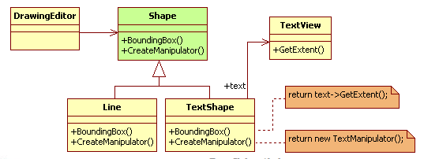
- Khi nào sử dụng:
- You want to use an existing class, and its interface does not
match the one you need
- You want to create a reusable class that cooperates with
unrelated or unforeseen classes, that is, classes that don't
necessarily have compatible interfaces
- You need to use several existing subclasses, but it's impractical
to adapt their interface by subclassing every one. An object
adapter can adapt the interface of its parent class
- Cấu trúc
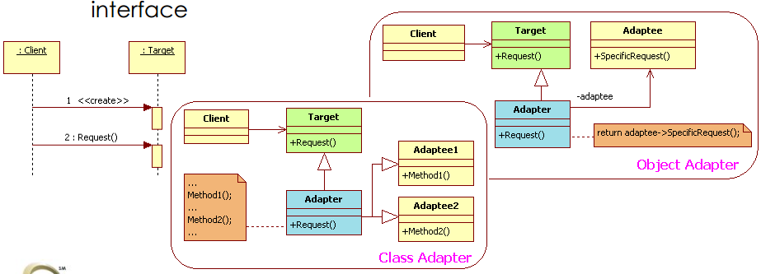
- Các thành viên - Sự cộng tác
- Target: Defines the domain-specific interface that Client uses
- Client: Collaborates with objects conforming to the Target
interface
- Adaptee: Defines an existing interface that needs adapting
- Adapter: Adapts the interface of Adaptee to the Target
interface
- Các hệ quả mang lại:
- Class adapter
• Adapts Adaptee to Target by committing to a concrete Adapter
class. As a consequence, a class adapter won't work when we
want to adapt a class and all its subclasses
• Lets Adapter override some of Adaptee's behavior, since Adapter
is a subclass of Adaptee
• Introduces only one object, and no additional pointer indirection
is needed to get to the adaptee
- Object adapter
• Lets a single Adapter work with many Adaptees – that is, the
Adaptee itself and all of its subclasses (if any). The Adapter can
also add functionality to all Adaptees at once
• Makes it harder to override Adaptee behavior. It will require
subclassing Adaptee and making Adapter refer to the subclass
rather than the Adaptee itself
- Chú ý liên quan đến cài đặt:

- Hệ thống thực tế

- Mẫu liên quan
- Bridge has a structure similar to an Object Adapter, but they
have a different intent:
• A Bridge is meant to separate an interface from its
implementation so that they can be varied easily and
independently
• An Adapter is meant to change the interface of an existing object
- Decorator enhances another object without changing its
interface. A decorator is thus more transparent to the
application than an Adapter is. As a consequence, Decorator
supports recursive composition, which isn't possible with pure
Adapters
- Proxy defines a representative or surrogate for another object
and does not change its interface

